|  |
| --- |
|  |
| SOVY |
| Digital Calculator PO1_DGC_GDD |

Table of Contents

1. Document Status 3

2. Document History 4

3. Reference Documents 4

4. Project Description 4

5. Software Context Diagram 5

6. Component’s Application Programming Interfaces (API’s) 6

# Document Status

|  |  |
| --- | --- |
| Name | SOVY |
| Version | 1.0 |
| Status | Proposed |
| Author | Nour Elgammal |
| Date | 16/4/2021 |

# Document History

|  |  |  |  |
| --- | --- | --- | --- |
| Version | Author | Date | Change |
| 1.0 | Nour Elgammal | 16/4/2021 | Initial Creation. |

# Reference Documents

|  |  |  |  |
| --- | --- | --- | --- |
| Ref. No. | Doc. Name | Version | Status |
| 1 | PO1_DGC_SRS_DigitalCalculator | 1.4 | proposed |
| 2 | PO1_DGC_GDD_DigitalCalculator | 1.3 | Proposed |

# Project Description

“Sovy” is a simple digital calculator that performs basic mathematical operations and displays the operation on an LCD-screen, with an ON/OFF button and keypad for user input.

# Software Context Diagram

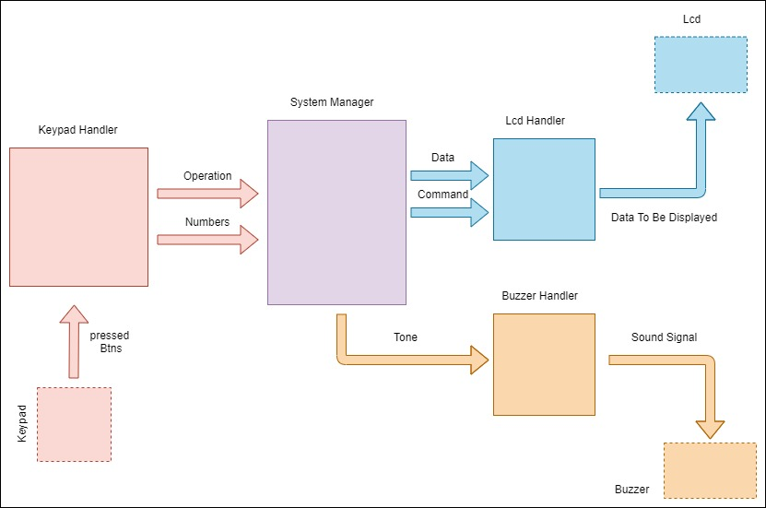

# 6. Component’s Application Programming Interfaces (API’s)

|  |  |  |  |  |  |  |
| --- | --- | --- | --- | --- | --- | --- |
| **Req_ID** | | Req_PO1__DGC_CDD_overall_001-V1.0 | | | | |
| **Covers** | | Req_PO1_DGC_GDD_016-V1.0  Req_1ST123_SRS_overall_026-V1.1  Req_1ST123_SRS_overall_027-V1.1 | | | | |
| **Author** | Nour Elgammal | **Date** | 16/4/2021 | | | |
| **API_Name** | ReturnStatus_e Buzzer_SetState(u8 State) | **Scope** | Public | | | |
| **Description** | | It sets the buzzer state according to its configuration file which configures its port and pin. | | | | |
| **Parameters** | | **Type** | | **Name** | **Description** | **Range** |
| u8 | | State | Buzzer state to set its pin to this state  High -> 1  Low -> 0 | u8 |
| **Return** | | ReturnStatus_e | | NA | STD_ERORR  E_OK -> If the function initialized the LCD successfully  E_NOK -> If any problem occurred while initializing the LCD | NA |
| **Algorithm** | |  | | | | |